Emergency Rescue Priority System

#include <stdio.h>
#include <string.h>
#include <stdlib.h>

struct EmerReq {
char req_id[50];
char location[50];
int no_of_people;
char emglvl[50];
char team[50];
char resource[50];
char status[50];
int priority;
};

enum rescueteam { team1, team2, team3, team4 };
enum priority { low = 1, medium, critical };

const char *teamNames[4] = {"Team1", "Team2", "Team3", "Team4"};
struct EmerReq records[100];
int teamBusy[4] = {0};
int count = 0;

int getPriority(char level[]) {
if (strcmp(level, "critical") == 0)
return critical;
if (strcmp(level, "medium") == 0)
return medium;
if (strcmp(level, "low") == 0)
return low;
return 0;
}

int findRequest(char id[]) {
for (int i = 0; i < count; i++) {
if (strcmp(records[i].req_id, id) == 0)
return i;
}
return -1;
}

void registerRequest() {
if (count >= 100) {
printf("Request limit reached!\n");
return;
}

struct EmerReq r;
printf("Enter Request ID: ");
scanf("%49s", r.req_id);

if (findRequest(r.req_id) != -1) {
printf("Request ID already exists!\n");
return;
}

printf("Enter Location: ");
scanf(" %49[^\n]", r.location);
printf("Enter Number of People: ");
scanf("%d", &r.no_of_people);

if (r.no_of_people <= 0) {
printf("Invalid number of people!\n");
return;
}

printf("Enter Emergency Level (critical/medium/low): ");
scanf("%49s", r.emglvl);
r.priority = getPriority(r.emglvl);

if (r.priority == 0) {
printf("Invalid emergency level!\n");
return;
}

printf("Enter Required Resource: ");
scanf(" %49[^\n]", r.resource);

strcpy(r.team, "Unassigned");
strcpy(r.status, "Pending");
records[count] = r;
count++;
printf("Emergency request registered successfully!\n");
}

void sortRequests() {
for (int i = 0; i < count - 1; i++) {
for (int j = i + 1; j < count; j++) {
if (records[i].priority < records[j].priority) {
struct EmerReq temp = records[i];
records[i] = records[j];
records[j] = temp;
}
}
}
}

void displayRequests() {
if (count == 0) {
printf("No emergency requests available!\n");
return;
}

sortRequests();
printf("\nRequests Sorted by Priority\n");

for (int i = 0; i < count; i++) {
printf("\nRequest ID: %s\n", records[i].req_id);
printf("Location: %s\n", records[i].location);
printf("People: %d\n", records[i].no_of_people);
printf("Emergency: %s\n", records[i].emglvl);
printf("Priority: %d\n", records[i].priority);
printf("Resource: %s\n", records[i].resource);
printf("Team: %s\n", records[i].team);
printf("Status: %s\n", records[i].status);
}
}

void assignTeam() {
char id[50];
printf("Enter Request ID: ");
scanf("%49s", id);

int found = findRequest(id);
if (found == -1) {
printf("Request not found!\n");
return;
}

if (strcmp(records[found].status, "Completed") == 0) {
printf("Request is already completed!\n");
return;
}

if (strcmp(records[found].team, "Unassigned") != 0) {
printf("A team is already assigned: %s\n", records[found].team);
return;
}

for (int i = 0; i < 4; i++) {
if (teamBusy[i] == 0) {
teamBusy[i] = 1;
strcpy(records[found].team, teamNames[i]);
strcpy(records[found].status, "InProgress");
printf("%s assigned to request %s\n", teamNames[i], records[found].req_id);
return;
}
}

printf("No rescue team is currently available!\n");
}

void updateStatus() {
char id[50], status[50];
printf("Enter Request ID: ");
scanf("%49s", id);

int found = findRequest(id);
if (found == -1) {
printf("Request not found!\n");
return;
}

printf("Enter new status (Pending/InProgress/Completed): ");
scanf("%49s", status);

if (strcmp(status, "Pending") != 0 &&
strcmp(status, "InProgress") != 0 &&
strcmp(status, "Completed") != 0) {
printf("Invalid status!\n");
return;
}

if (strcmp(records[found].status, "Completed") == 0) {
printf("Completed requests cannot be updated!\n");
return;
}

if (strcmp(status, "InProgress") == 0 &&
strcmp(records[found].team, "Unassigned") == 0) {
printf("Assign a rescue team before starting the request!\n");
return;
}

if (strcmp(status, "Completed") == 0 &&
strcmp(records[found].team, "Unassigned") != 0) {
for (int i = 0; i < 4; i++) {
if (strcmp(records[found].team, teamNames[i]) == 0)
teamBusy[i] = 0;
}
}

strcpy(records[found].status, status);
printf("Request status updated successfully!\n");
}

void searchRequest() {
char id[50];
printf("Enter Request ID: ");
scanf("%49s", id);

int found = findRequest(id);
if (found == -1) {
printf("Request not found!\n");
return;
}

printf("\nRequest ID: %s\n", records[found].req_id);
printf("Location: %s\n", records[found].location);
printf("People: %d\n", records[found].no_of_people);
printf("Emergency: %s\n", records[found].emglvl);
printf("Priority: %d\n", records[found].priority);
printf("Resource: %s\n", records[found].resource);
printf("Team: %s\n", records[found].team);
printf("Status: %s\n", records[found].status);
}

void emergencySummary() {
int criticalCount = 0, mediumCount = 0, lowCount = 0;
int pending = 0, inProgress = 0, completed = 0, people = 0;

for (int i = 0; i < count; i++) {
people += records[i].no_of_people;

if (records[i].priority == critical)
criticalCount++;
else if (records[i].priority == medium)
mediumCount++;
else if (records[i].priority == low)
lowCount++;

if (strcmp(records[i].status, "Pending") == 0)
pending++;
else if (strcmp(records[i].status, "InProgress") == 0)
inProgress++;
else if (strcmp(records[i].status, "Completed") == 0)
completed++;
}

printf("\nEmergency Summary\n");
printf("Total Requests: %d\n", count);
printf("Total People Affected: %d\n", people);
printf("Critical Requests: %d\n", criticalCount);
printf("Medium Requests: %d\n", mediumCount);
printf("Low Requests: %d\n", lowCount);
printf("Pending Requests: %d\n", pending);
printf("In Progress Requests: %d\n", inProgress);
printf("Completed Requests: %d\n", completed);
}

int main() {
int choice;

while (1) {
printf("\n===== Emergency Rescue Management =====\n");
printf("1. Register Emergency Request\n");
printf("2. Calculate and Assign Priority\n");
printf("3. Display Requests by Priority\n");
printf("4. Assign Rescue Team\n");
printf("5. Update Request Status\n");
printf("6. Search Request\n");
printf("7. Generate Emergency Summary\n");
printf("8. Exit\n");
printf("Enter your choice: ");

if (scanf("%d", &choice) != 1) {
printf("Invalid input!\n");
break;
}

switch (choice) {
case 1:
registerRequest();
break;
case 2:
for (int i = 0; i < count; i++)
records[i].priority = getPriority(records[i].emglvl);
sortRequests();
printf("Priorities calculated and requests sorted!\n");
break;
case 3:
displayRequests();
break;
case 4:
assignTeam();
break;
case 5:
updateStatus();
break;
case 6:
searchRequest();
break;
case 7:
emergencySummary();
break;
case 8:
printf("Exiting program...\n");
return 0;
default:
printf("Invalid choice!\n");
}
}

return 0;
}

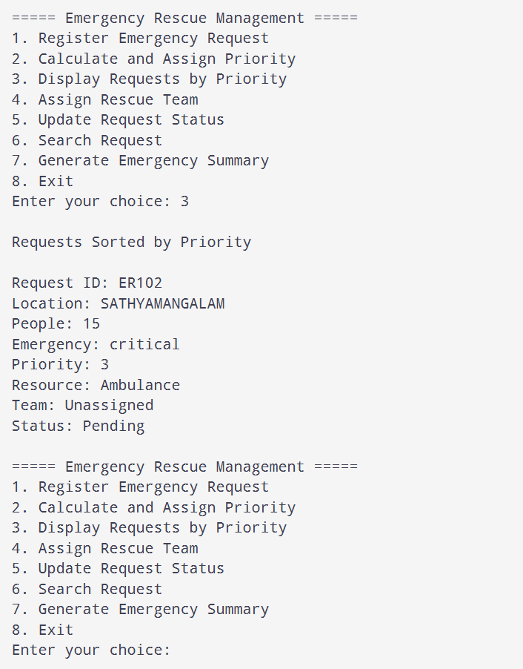

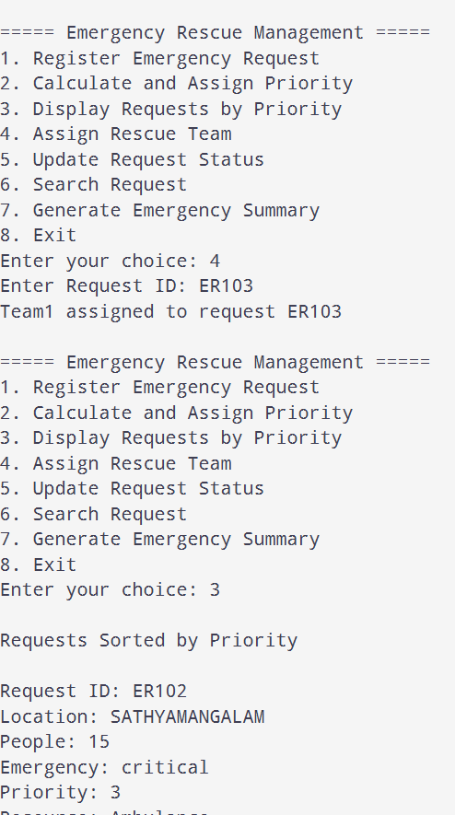

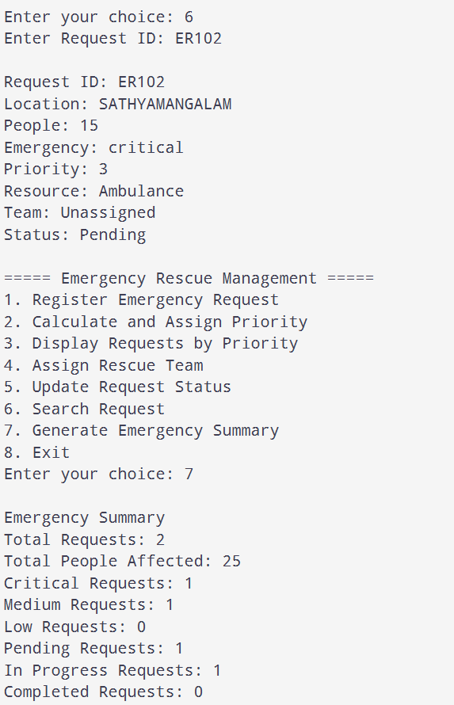
Smart Campus Complaint System

#include <stdio.h>
#include <string.h>

struct Complaint {
char id[50];
char category[50];
char problem[150];
char location[100];
char severity[20];
char status[30];
int priority;
};

enum Priority { LOW = 1, MEDIUM, HIGH, CRITICAL };

struct Complaint complaints[100];
int count = 0;

int getPriority(char severity[]) {
if (strcmp(severity, "Critical") == 0)
return CRITICAL;
if (strcmp(severity, "High") == 0)
return HIGH;
if (strcmp(severity, "Medium") == 0)
return MEDIUM;
if (strcmp(severity, "Low") == 0)
return LOW;
return 0;
}

char *priorityName(int priority) {

switch (priority) {

case CRITICAL: return "Critical";

case HIGH: return "High";

case MEDIUM: return "Medium";

case LOW: return "Low";
default: return "Unknown";
}
}

int findComplaint(char id[]) {
for (int i = 0; i < count; i++) {
if (strcmp(complaints[i].id, id) == 0)
return i;
}
return -1;
}

void registerComplaint() {
if (count >= 100) {
printf("Complaint limit reached!\n");
return;
}

struct Complaint c;
printf("Enter Complaint ID: ");
scanf("%49s", c.id);

if (findComplaint(c.id) != -1) {
printf("Complaint ID already exists!\n");
return;
}

printf("Enter Category: ");
scanf(" %49[^\n]", c.category);
printf("Enter Problem Description: ");
scanf(" %149[^\n]", c.problem);
printf("Enter Location: ");
scanf(" %99[^\n]", c.location);
printf("Enter Severity (Critical/High/Medium/Low): ");
scanf("%19s", c.severity);

c.priority = getPriority(c.severity);
if (c.priority == 0) {
printf("Invalid severity!\n");
return;
}

strcpy(c.status, "Pending");
complaints[count] = c;
count++;
printf("Complaint registered successfully!\n");
}

void displayComplaint(struct Complaint c) {
printf("\nComplaint ID: %s\n", c.id);
printf("Category: %s\n", c.category);
printf("Problem: %s\n", c.problem);
printf("Location: %s\n", c.location);
printf("Priority: %s\n", priorityName(c.priority));
printf("Status: %s\n", c.status);
}

void sortComplaints() {
int choice;
printf("Sort by:\n");
printf("1. Priority\n");
printf("2. Complaint ID\n");
printf("3. Category\n");
printf("Enter choice: ");
scanf("%d", &choice);

for (int i = 0; i < count - 1; i++) {
for (int j = i + 1; j < count; j++) {
int swap = 0;

if (choice == 1 && complaints[i].priority < complaints[j].priority)
swap = 1;
else if (choice == 2 && strcmp(complaints[i].id, complaints[j].id) > 0)
swap = 1;
else if (choice == 3 && strcmp(complaints[i].category, complaints[j].category) > 0)
swap = 1;

if (swap) {
struct Complaint temp = complaints[i];
complaints[i] = complaints[j];
complaints[j] = temp;
}
}
}

printf("Complaints sorted successfully!\n");
}

void displayAllComplaints() {
if (count == 0) {
printf("No complaints registered!\n");
return;
}

for (int i = 0; i < count; i++)
displayComplaint(complaints[i]);
}

void searchComplaint() {
int choice, found = 0;
char searchValue[150];

printf("Search by:\n");
printf("1. Complaint ID\n");
printf("2. Category\n");
printf("3. Location\n");
printf("Enter choice: ");
scanf("%d", &choice);
printf("Enter search value: ");
scanf(" %149[^\n]", searchValue);

for (int i = 0; i < count; i++) {
int match = 0;

if (choice == 1 && strcmp(complaints[i].id, searchValue) == 0)
match = 1;
else if (choice == 2 && strcmp(complaints[i].category, searchValue) == 0)
match = 1;
else if (choice == 3 && strcmp(complaints[i].location, searchValue) == 0)
match = 1;

if (match) {
displayComplaint(complaints[i]);
found = 1;
}
}

if (!found)
printf("No matching complaint found!\n");
}

void updateStatus() {
char id[50], status[30];
printf("Enter Complaint ID: ");
scanf("%49s", id);

int found = findComplaint(id);
if (found == -1) {
printf("Complaint not found!\n");
return;
}

printf("Enter new status (Pending/InProgress/Resolved): ");
scanf("%29s", status);

if (strcmp(status, "Pending") != 0 &&

strcmp(status, "InProgress") != 0 &&

strcmp(status, "Resolved") != 0) {
printf("Invalid status!\n");
return;
}

strcpy(complaints[found].status, status);

printf("Complaint status updated successfully!\n");
}

void displayPending() {
int found = 0;

for (int i = 0; i < count; i++) {
if (strcmp(complaints[i].status, "Pending") == 0) {
displayComplaint(complaints[i]);
found = 1;
}
}

if (!found)
printf("No pending complaints!\n");
}

void complaintSummary() {
int critical = 0, high = 0, medium = 0, low = 0;

int pending = 0, progress = 0, resolved = 0;

for (int i = 0; i < count; i++) {
switch (complaints[i].priority) {

case CRITICAL: critical++; break;
case HIGH: high++;
break;

case MEDIUM: medium++;
break;
case LOW: low++; break;
}

if (strcmp(complaints[i].status, "Pending") == 0)
pending++;
else if (strcmp(complaints[i].status, "InProgress") == 0)
progress++;

else if (strcmp(complaints[i].status, "Resolved") == 0)
resolved++;

}

printf("\n===== Complaint Summary =====\n");
printf("Total Complaints: %d\n", count);
printf("Critical Priority: %d\n", critical);
printf("High Priority: %d\n", high);
printf("Medium Priority: %d\n", medium);
printf("Low Priority: %d\n", low);
printf("Pending: %d\n", pending);
printf("In Progress: %d\n", progress);
printf("Resolved: %d\n", resolved);
}

int main() {
int choice;

while (1) {
printf("\n===== Campus Complaint Management =====\n");
printf("1. Register Complaint\n");
printf("2. Assign Priority\n");
printf("3. Search Complaint\n");
printf("4. Sort Complaints\n");
printf("5. Update Complaint Status\n");
printf("6. Display Pending Complaints\n");
printf("7. Generate Complaint Summary\n");
printf("8. Display All Complaints\n");
printf("9. Exit\n");
printf("Enter your choice: ");

if (scanf("%d", &choice) != 1) {
printf("Invalid input!\n");
break;
}

switch (choice) {

case 1:
registerComplaint();
Break;

case 2:
for (int i = 0; i < count; i++)
complaints[i].priority = getPriority(complaints[i].severity);

printf("Complaint priorities calculated successfully!\n");

break;
case 3:
searchComplaint();
break;
case 4:
sortComplaints();
break;
case 5:
updateStatus();
break;
case 6:
displayPending();
break;
case 7:
complaintSummary();
break;
case 8:

displayAllComplaints();
break;
case 9:

printf("Exiting program...\n");
return 0;
default:

printf("Invalid choice!\n");
}
}

return 0;
}

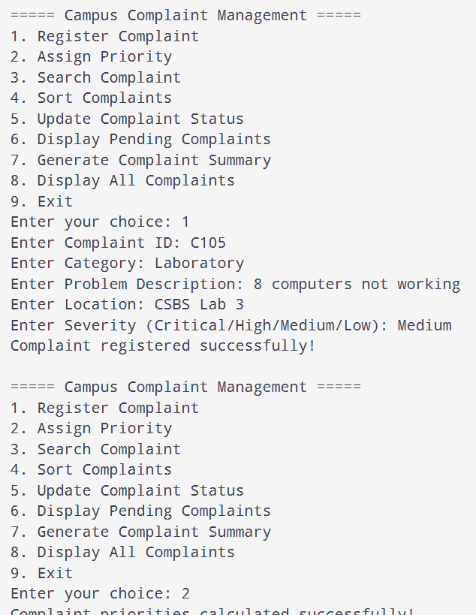

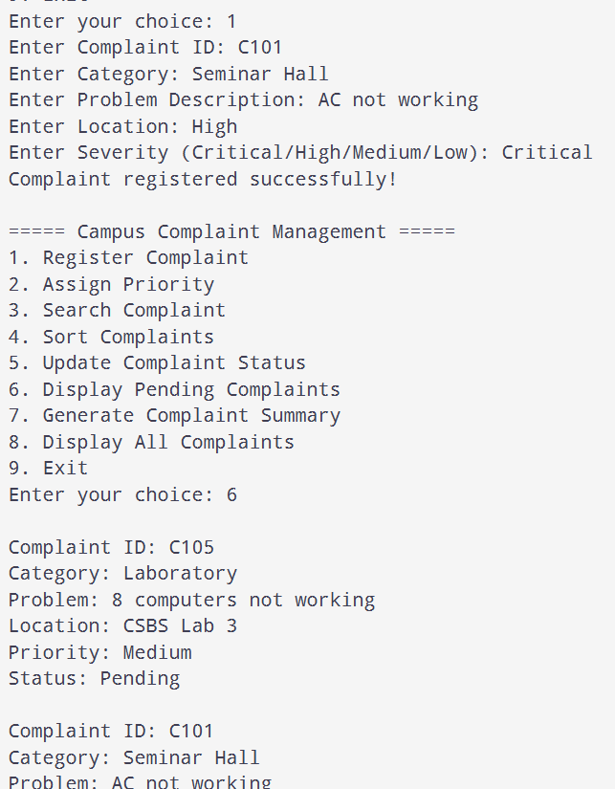

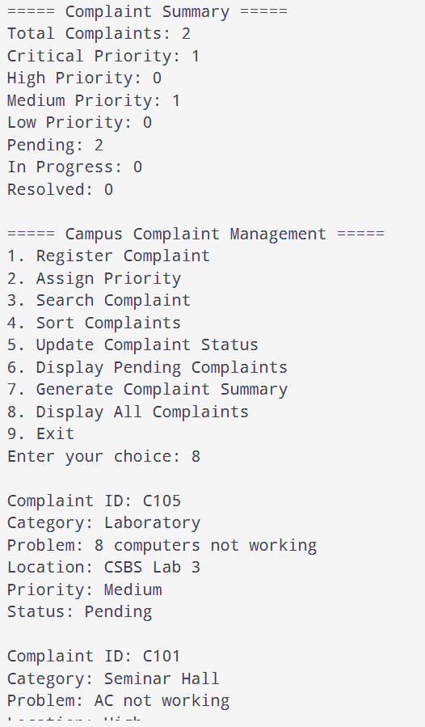

Smart Hospital Emergency Queue System

#include <stdio.h>
#include <string.h>

struct Patient {
char id[50];
char name[50];
int age;
char condition[100];
int priority;
char status[30];
char doctor[50];
char bed[50];
};

enum Priority { CRITICAL = 1, HIGH, MEDIUM, LOW };

struct Patient patients[100];
char doctorNames[4][50] = {"Doctor1", "Doctor2", "Doctor3", "Doctor4"};
char bedNames[4][50] = {"Bed1", "Bed2", "Bed3", "Bed4"};
int doctorBusy[4] = {0}, bedBusy[4] = {0};
int count = 0;

int findPatient(char id[]) {
for (int i = 0; i < count; i++) {
if (strcmp(patients[i].id, id) == 0)
return i;
}
return -1;
}

int getPriority(int choice) {
if (choice >= CRITICAL && choice <= LOW)
return choice;
return 0;
}

char *priorityName(int priority) {
switch (priority) {
case CRITICAL: return "Critical";
case HIGH: return "High";
case MEDIUM: return "Medium";
case LOW: return "Low";
default: return "Unknown";
}
}

void registerPatient() {
if (count >= 100) {
printf("Patient limit reached!\n");
return;
}

struct Patient p;
printf("Enter Patient ID: ");
scanf("%49s", p.id);

if (findPatient(p.id) != -1) {
printf("Patient ID already exists!\n");
return;
}

printf("Enter Patient Name: ");
scanf(" %49[^\n]", p.name);
printf("Enter Age: ");
scanf("%d", &p.age);

if (p.age <= 0 || p.age > 130) {
printf("Invalid age!\n");
return;
}

printf("Enter Patient Condition: ");
scanf(" %99[^\n]", p.condition);
printf("Enter Priority (1-Critical, 2-High, 3-Medium, 4-Low): ");
scanf("%d", &p.priority);

p.priority = getPriority(p.priority);
if (p.priority == 0) {
printf("Invalid priority!\n");
return;
}

strcpy(p.status, "Waiting");
strcpy(p.doctor, "Unassigned");
strcpy(p.bed, "Unassigned");
patients[count] = p;
count++;

printf("Patient registered successfully!\n");
}

void displayPatient(struct Patient p) {
printf("\nPatient ID: %s\n", p.id);
printf("Name: %s\n", p.name);
printf("Age: %d\n", p.age);
printf("Condition: %s\n", p.condition);
printf("Priority: %d - %s\n", p.priority, priorityName(p.priority));
printf("Status: %s\n", p.status);
printf("Doctor: %s\n", p.doctor);
printf("Bed: %s\n", p.bed);
}

void sortPatients() {
for (int i = 0; i < count - 1; i++) {
for (int j = i + 1; j < count; j++) {
if (patients[i].priority > patients[j].priority) {
struct Patient temp = patients[i];
patients[i] = patients[j];
patients[j] = temp;
}
}
}
}

void displayPatients() {
if (count == 0) {
printf("No patients registered!\n");
return;
}

sortPatients();
printf("\nPatients in Priority Order\n");

for (int i = 0; i < count; i++)
displayPatient(patients[i]);
}

void callNextPatient() {
sortPatients();

for (int i = 0; i < count; i++) {
if (strcmp(patients[i].status, "Waiting") == 0) {
printf("\nNext Patient Called\n");
displayPatient(patients[i]);
return;
}
}

printf("No patients are waiting!\n");
}

void assignDoctorBed() {
char id[50];
printf("Enter Patient ID: ");
scanf("%49s", id);

int found = findPatient(id);
if (found == -1) {
printf("Patient not found!\n");
return;
}

if (strcmp(patients[found].status, "Completed") == 0) {
printf("Treatment is already completed!\n");
return;
}

int doctor = -1, bed = -1;

if (strcmp(patients[found].doctor, "Unassigned") != 0) {
printf("Doctor already assigned: %s\n", patients[found].doctor);
} else {
for (int i = 0; i < 4; i++) {
if (doctorBusy[i] == 0) {
doctor = i;
break;
}
}

if (doctor == -1) {
printf("No doctor available!\n");
return;
}
}

if (strcmp(patients[found].bed, "Unassigned") != 0) {
printf("Bed already assigned: %s\n", patients[found].bed);
} else {
for (int i = 0; i < 4; i++) {
if (bedBusy[i] == 0) {
bed = i;
break;
}
}

if (bed == -1) {
printf("No bed available!\n");
return;
}
}

if (doctor != -1) {
doctorBusy[doctor] = 1;
strcpy(patients[found].doctor, doctorNames[doctor]);
}

if (bed != -1) {
bedBusy[bed] = 1;
strcpy(patients[found].bed, bedNames[bed]);
}

strcpy(patients[found].status, "InTreatment");
printf("Doctor and bed assignment completed!\n");
displayPatient(patients[found]);
}

void updateStatus() {
char id[50], status[30];
printf("Enter Patient ID: ");
scanf("%49s", id);

int found = findPatient(id);
if (found == -1) {
printf("Patient not found!\n");
return;
}

printf("Enter Status (Waiting/InTreatment/Completed): ");
scanf("%29s", status);

if (strcmp(status, "Waiting") != 0 &&
strcmp(status, "InTreatment") != 0 &&
strcmp(status, "Completed") != 0) {
printf("Invalid status!\n");
return;
}

if (strcmp(patients[found].status, "Completed") == 0) {
printf("Completed patient records cannot be updated!\n");
return;
}

if (strcmp(status, "InTreatment") == 0 &&
(strcmp(patients[found].doctor, "Unassigned") == 0 ||
strcmp(patients[found].bed, "Unassigned") == 0)) {
printf("Assign a doctor and bed before starting treatment!\n");
return;
}

if (strcmp(status, "Completed") == 0) {
for (int i = 0; i < 4; i++) {
if (strcmp(patients[found].doctor, doctorNames[i]) == 0)
doctorBusy[i] = 0;

if (strcmp(patients[found].bed, bedNames[i]) == 0)
bedBusy[i] = 0;

}

strcpy(patients[found].doctor, "Unassigned");

strcpy(patients[found].bed, "Unassigned");
}

strcpy(patients[found].status, status);

printf("Patient status updated successfully!\n");
}

void searchPatient() {
char id[50];
printf("Enter Patient ID: ");
scanf("%49s", id);

int found = findPatient(id);
if (found == -1) {
printf("Patient not found!\n");
return;
}

displayPatient(patients[found]);
}

void emergencySummary() {

int waiting = 0, treatment = 0, completed = 0;

int critical = 0, high = 0, medium = 0, low = 0;

for (int i = 0; i < count; i++) {
if (strcmp(patients[i].status, "Waiting") == 0)
waiting++;
else if (strcmp(patients[i].status, "InTreatment") == 0)
treatment++;
else if (strcmp(patients[i].status, "Completed") == 0)
completed++;

switch (patients[i].priority) {
case CRITICAL: critical++; break;
case HIGH: high++; break;
case MEDIUM: medium++; break;
case LOW: low++; break;
}
}

printf("\n===== Emergency Department Summary =====\n");
printf("Total Patients: %d\n", count);
printf("Waiting Patients: %d\n", waiting);
printf("Patients in Treatment: %d\n", treatment);
printf("Completed Treatments: %d\n", completed);
printf("Critical Patients: %d\n", critical);
printf("High Priority Patients: %d\n", high);
printf("Medium Priority Patients: %d\n", medium);
printf("Low Priority Patients: %d\n", low);
}

int main() {
int choice;

while (1) {
printf("\n===== Smart Hospital Emergency Queue =====\n");
printf("1. Register Patient\n");
printf("2. Assign Emergency Priority\n");
printf("3. Display Patients by Priority\n");
printf("4. Call Next Patient\n");
printf("5. Assign Doctor and Bed\n");
printf("6. Update Patient Status\n");
printf("7. Search Patient\n");
printf("8. Generate Emergency Summary\n");
printf("9. Exit\n");
printf("Enter your choice: ");

if (scanf("%d", &choice) != 1) {
printf("Invalid input!\n");
break;
}

switch (choice) {
case 1:

registerPatient();
break;
case 2:

for (int i = 0; i < count; i++) {
if (patients[i].priority >= CRITICAL &&
patients[i].priority <= LOW)
patients[i].priority = getPriority(patients[i].priority);
}
printf("Emergency priorities verified!\n");
break;
case 3:
displayPatients();
break;
case 4:
callNextPatient();
break;
case 5:
assignDoctorBed();
break;
case 6:
updateStatus();
break;
case 7:
searchPatient();
break;
case 8:
emergencySummary();
break;

case 9:

printf("Exiting program...\n");
return 0;
default:
printf("Invalid choice!\n");
}

}

return 0;
}

